* Service Codes  E = Elder Care Checks  C/D/M = Courier/Delivery/Messenger Service  GE = General Errands  GS = Grocery Shopping  HS = House Sitting  L/D = Lunch/Dinner Delivery  MDPB = Mid-Day Pet Break | O = Other (Please specify service here)  PET = Pet Sitting  PS = Personal Shopping  PT = Pet Taxi  PW = Pet Walking  RS = Reminder Service  WS = Waiting Service

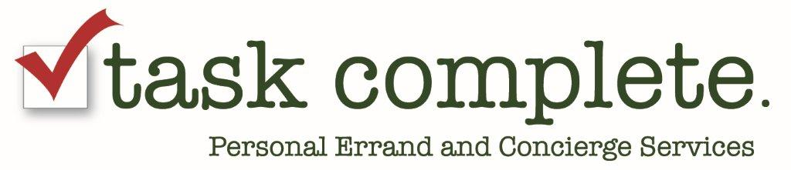

ERRAND LOG

Date
Signature of Errand Runner
Signature of Personnel
CLIENT # | ERRAND ORDER # | SERVICE CODES* | AMOUNT OF PURCHASE | SPECIAL NOTES (Include Pick Up Location or Special Items needed)

* 717-746-TASK * www.taskcomplete.com * Kelly@taskcomplete.com *

