Daily PET Check Journal
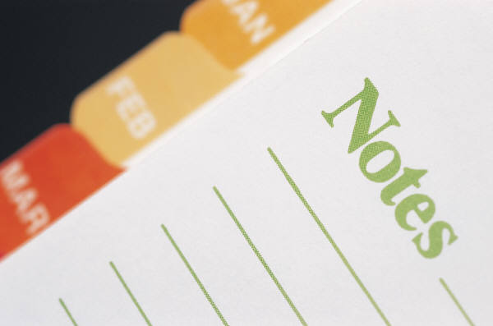

Date of Visit: ___________________________ Time of Visit: ___________ AM ___________ PM

Did Sitter make sure the following happened:

- House secure after entering? YES NO
- Water plants? YES NO
- Bring in the mail? YES NO
- Bring in the newspaper? YES NO
- Turn lights on/off? YES NO
- Take out trash? YES NO
- Open/close blinds? YES NO
- House locked after leaving? YES NO

If the answer was “No” to any of the above tasks, please explain why not: _________________________

_____________________________________________________________________________________

_____________________________________________________________________________________

_____________________________________________________________________________________

Did Sitter tend to pets (if applicable)? YES NO Pet Treats Given: YES NO

Feeding Time: What ate? ________________________________ Amount? _______________________

Exercise Time: What did? _______________________________________________________________

Medications: Y N If yes, what time/dosage/medication given? _______________________________

Was litter box/yard cleaned of messes? YES NO Pet taken to vet for any reason? YES NO

Behavior: Excellent Good Average Below Average Poor

What other events took place during visit? __________________________________________________

_____________________________________________________________________________________

_____________________________________________________________________________________

_____________________________________________________________________________________

Tape picture of pet or house taken during visit here

Signature of Sitter: _____________________________________________________________________

* 717-746-TASK * www.taskcomplete.com * Kelly@taskcomplete.com *

