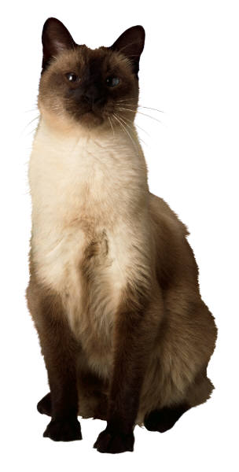
Cat Information Form

Owner: |  |  |  |  |  | Pet Name:
Length of time owned: |  |  |  |  |  | Sex:
Breed: |  |  |  |  |  | Age:
Size: |  |  |  |  |  | Color:
Special Markings: |  |  |  |  |  | Spayed:
Pet License # |  |  |  |  |  | Neutered:
Proof of vaccinations: |  |  |  |  |  | Pregnant:

History of illness (including allergies, illnesses, injuries, and treatments):

Is your cat currently contagious? | Yes | No
(In order to protect the health and well being of your pets, other clients’ pets, and our own pets, we provide additional care and preventive measures when handling cat that have contagious illnesses.)

Pet’s background (i.e. adopted from shelter, purchased as a kitten):

Do you provide your animal with flea or tick control? | Yes | No
Do you use heartworm preventive for your animal? | Yes | No

Feeding Instructions:
Food amount:
Dry: |  |  |  |  | Wet:
Do you want us to mix the wet and dry food? |  |  |  | Yes |  | No
Feeding times:

Feeding Directions: |  |  |  |  | Watch during feedings |  |  |  |  |  | Separate dishes |  |  | Fill bowl & leave alone
 | Remove dish after _____ minutes |  |  |  |  |  |  | Other
Dish location:
Water amount and type: |  |  |  |  |  |  |  |  |  |  |  |  | Tap |  | Filtered | Bottled
Dish location:
Water location:

Treats type, amount, and time to be given:

Pet food/Treats located:
Location of brush/comb or other pet supplies:
Clean Litter Box: | Y | N |  | # of times |  |  | Location:
Disposal of litter box contents:

Is your cat allowed outdoors? | Y | N | Does cat stay outdoors during the day? | Y | N
Is your cat prone to hairballs? | Y | N | Does your pet like to be combed/brushed? | Y | N

Does your animal try to escape when the door is opened? |  |  | Y | N
What is the best way to bring your pet back?
Where does your pet go when they escape?

Is your animal skittish with strangers? | Y | N
What do you do to ease their anxiety?

Have you had any trouble with the neighbors or animal regarding your pet? |  |  |  |  |  |  | Y | N
If so, what has been the problem?
Does your cat have any favorite hiding places? |  |  | Y | N | Where:
What do you do to bring them out of hiding?

Is pet friendly with other animals: |  |  | Y |  |  | N |  | If no, please explain:
Is pet friendly with people? | Y | N |  | If no, please explain:
Has your pet ever scratched anyone? |  |  |  |  | Y |  | N |  | Who?

When upset, does your cat:
Hiss | Arch it’s back | Fold it’s ears down | Lash its tail from side to side

What do you do to calm your pet down:

Are there strong dislikes/fears your pet(s) have? | Y | N | (Ex: thunder, fireworks, loud noises)

Are there any areas of your home/rooms or furniture where your pet(s) is not allowed?

Are there any areas in your neighborhood your pet(s) should not be taken:

Does your cat have a special place to claw? (Ex: scratching post, old couch)

Special notes (favorite toys, games, activities, temperament, etc):

Vet’s name: |  |  | Phone:
Address:
If we are unable to reach your vet, may we use ours? |  |  |  | YES |  | NO

Our pet(s) are:
 | Declawed |  | Not declawed
 | Microchipped |  | Wearing tags with current information
 | Not Microchipped |  | Not wearing tags
 | Identification photos are attached |  | Identification photos are not attached

Client’s signature __________________________________________ Date _______________

Pet Sitter signature _________________________________________ Date _______________

* 717-746-TASK * www.taskcomplete.com * Kelly@taskcomplete.com *

