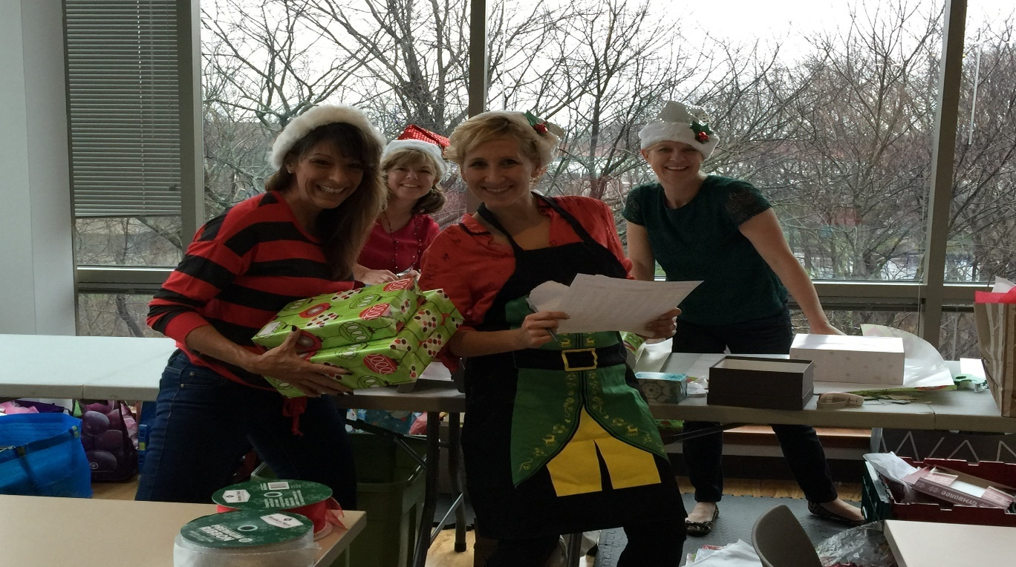

The holiday season is supposed to be a relaxing time meant for spending time with friends and familiy as a way to reflect back on the year. In reality however, the holidays come filled with stress and overwhelm, sleepless nights and anxiety. There are work, family, and friend obligations that all need attention. In the end the holidays often feel more like a burden than a chance to reconnect with our friends and family…

But have NO fear!! Task Complete has a long standing tradition of bringing more JOY and far less worry to your world during the holidays!

Allow our EXPERT Elves to shop, wrap, or even decorate your home or office! Have 20 local business contacts you wish to shower with cheer? We have you covered there too! Our Elves are expertly trained to take the worry and overwhelm OUT of your holidays so you can focus on the enjoyment that they are meant to bring.

So back this year by Popular demand are our “Rent an Elf” packages!!

For a VERY limited time we are selling our Elf packages for just $110!! That is just crazy pants… But we do it for YOU!
( All packages must be redeemed by Dec 16th ) ( Limit of 2 packages per household )

