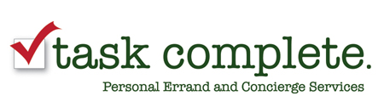

Option #1
4 hours of personal shopping services per employee based on 70 employees to be used during the time frame set by both parties. Each employee will have access to their own personal shopper to discuss their own shopping needs. Lists will created and communication will occur either via phone or email.
$8400 (This works out to the cost of $135 Per employee)
Normal Rate would be $12,600

Bonus Add-on at a rate of $1000: Wrapping party as described in Option #3.

Option #2
2 hours of personal shopping services per employee based on 70 employees. 4 shopping days will be designated in advance for employees. Last day will be no later than Dec 15th. Online shopping can gladly be extended until Dec 19th. Each employee will have access to their own personal shopper to discuss their own shopping needs. Lists will created and communication will occur either via phone or email.
$4200 ( This works out to a cost < $75. Per employee )
Normal Rate would be $6300
Bonus Add-on at a rate of $1000: Wrapping party as described in Option #3.

Option #3

Wrapping Party:
Flat fee for 4 elves on site to wrap at the Horsham office for up to 8 hrs. All wrapping supplies, tags, paper and bows ARE included.
$1500 ( This is < $25. Per employee )
Based on employee response, additional days may be added at a rate of $1200/day.
If you want us to plan a caterer, music and décor this can be added at an additional cost.

We are a full service concierge provider based in Bucks County PA with clients across the globe. We are fully insured and bonded.

Thank you for your consideration,

Kellyann Schaefer
kelly@taskcomplete.com
Task Complete
267-334-6927

