Is the season not so jolly for you?


Are you one of the 40% of people who do not want to fight crowds to go holiday shopping?

Are your employees stressed with the idea of all they have to do?

With the end of the year fast approaching and the flurry of errands that have to be done, your work and personal obligations still need to be taken care of.

Task Complete is here to help you gain more time. Whatever YOUR needs, we are here to help YOU!
Some of the end of the year services we are offering are:

Decorating
Gift Baskets
Gift Delivery
Gift Exchange/Return
Gift shopping
Gift Wrapping
House/Pet Sitting
Party Help
Party Planning
Post Office Needs



Call us today for your FREE consultation. Let us know if there are any other services that we can help you with that you don’t see listed.

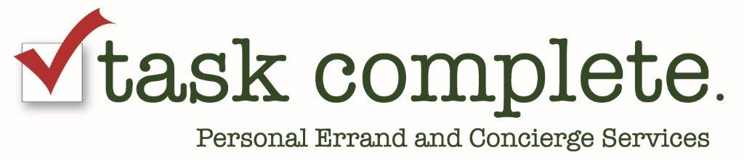

267-334-6927
www.taskcomplete.com
Kelly@taskcomplete.com

